Supplementary Table 1 Ablation study of different components
Model Masking module Raw data input
SGMHA ✓ ✓
SGMHA w/o M ✓ ×
SGMHA w/o R × ✓
The check mark indicates the component is included, while the cross indicates it is removed.

Supplementary Table 2 Metastasis related signaling pathways and functional enrichment results
Pathway | P_{m}
FoxO signaling pathway | 1.38E-12
ErbB signaling pathway | 2.48E-12
HIF-1 signaling pathway | 3.86E-10
mTOR signaling pathway | 8.92E-09
Estrogen signaling pathway | 3.24E-08
VEGF signaling pathway | 1.33E-06
PI3K-Akt signaling pathway | 5.03E-05
Hippo signaling pathway | 5.56E-05
MAPK signaling pathway | 6.23E-04
Wnt signaling pathway | 8.92E-04
Rap1 signaling pathway | 1.03E-04
Jak-STAT signaling pathway | 1.77E-02
Notch signaling pathway | 1.34E-02
positive regulation of cell migration (GO:0030335) | 3.51E-05
positive regulation of epithelial to mesenchymal transition (GO:0010718) | 1.05E-03
negative regulation of apoptotic process (GO:0043066) | 6.54E-20
negative regulation of cell-substrate adhesion (GO:0010812) | 2.47E-05

Supplementary Table 3 Key signaling pathways enrichment results of intersect genes
Pathway | P
ErbB signaling pathway | 1.54E-05
HIF-1 signaling pathway | 4.13E-05
VEGF signaling pathway | 1.68E-04
Jak-STAT signaling pathway | 1.93E-04
C-type lectin receptor signaling pathway | 8.94E-04
mTOR signaling pathway | 2.71E-03
PI3K-Akt signaling pathway | 3.62E-03
Rap1 signaling pathway | 6.61E-03
Notch signaling pathway (GO:0007219) | 2.37E-02
ERBB2 signaling pathway (GO:0038128) | 4.20E-02
ERK1 and ERK2 cascade (GO:0070371) | 5.46E-04
MAPK cascade (GO:0000165) | 2.82E-02
positive regulation of ERK1 and ERK2 cascade (GO:0070374) | 2.54E-02
beta-catenin-TCF complex assembly (GO:1904837) | 7.31E-04
MAML1-RBP-Jkappa- ICN1 complex (GO:0002193) | 4.01E-03

Supplementary Table 4 K-M survival analysis results of intersect genes
Gene | P_{k-m}
RBM8A | 0.08
HRAS | 0.07
PIK3R1 | 0.23
GRSF1 | 2.4E-12
ITM2B | 0.36
PIK3R3 | 0.23
CP | 0.23
EGLN1 | 0.09
NOL7 | 9E-03
NDUFAF4 | 1.1E-05
UCHL5 | 0.01
NDRG2 | 0.04
ENY2 | 2.1E-04
CDC73 | 0.02
NOTCH1 | 0.05
NUDT1 | 0.23
BRCA2 | 0.13

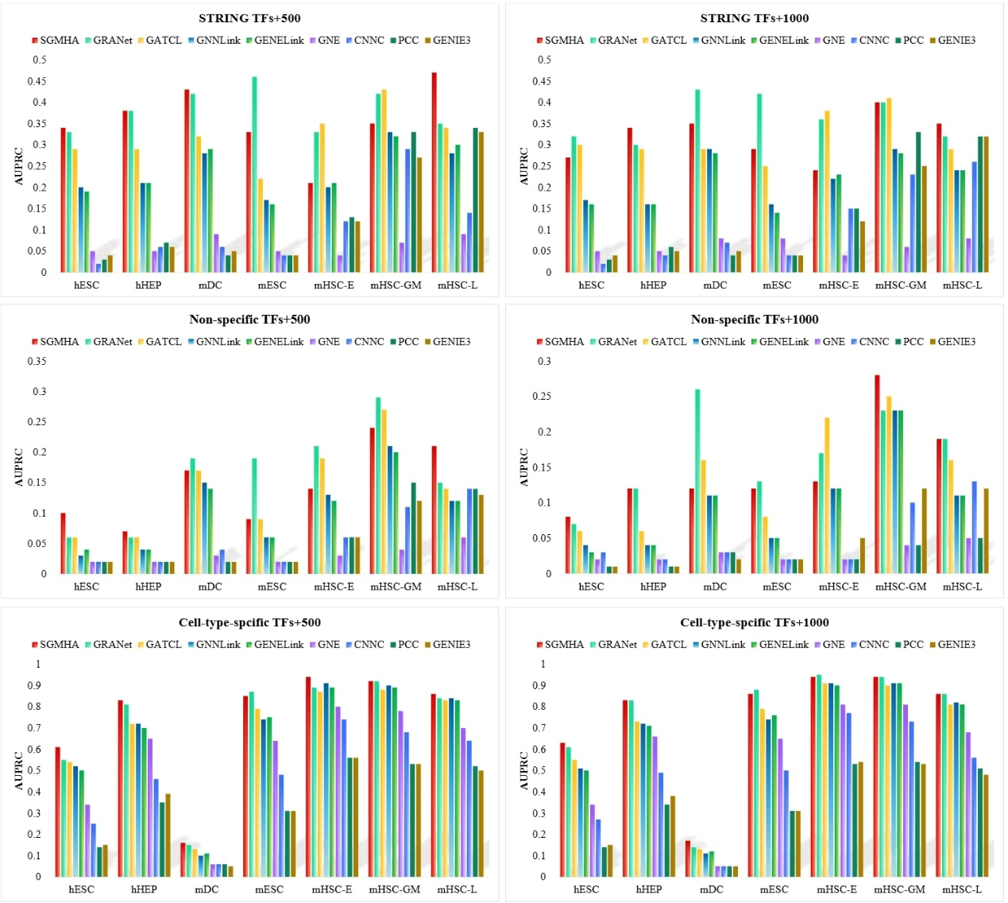
Supplementary Figure 1 Average AUPRC scores of nine models across three ground-truth networks on seven kinds of datasets.

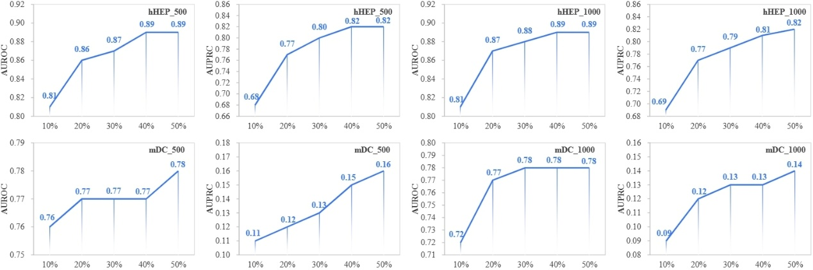
Supplementary Figure 2 Performance of SGMHA on hHEP and mDC scRNA-seq datasets across training set sizes (10\%-50\%), evaluated using the cell-type-specific ChIP-seq network.

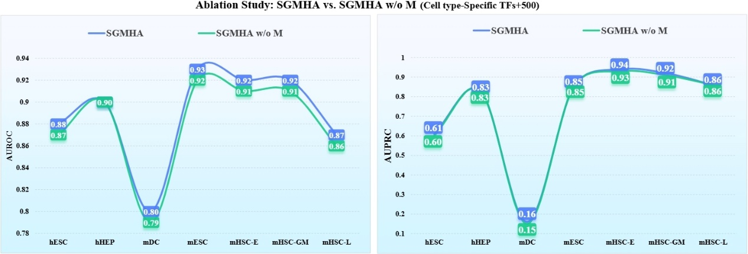
Supplementary Figure 3 Ablation study comparing SGMHA and its variant SGMHA w/o M on the TFs+500 dataset.

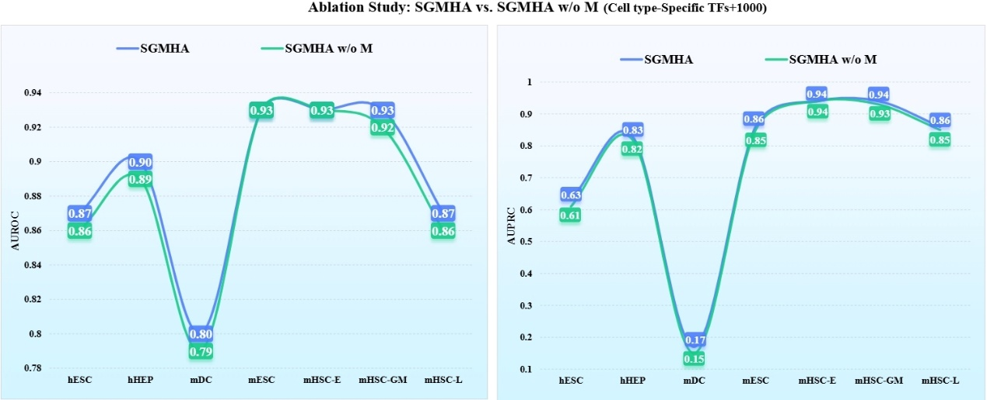
Supplementary Figure 4 Ablation study comparing SGMHA and its variant SGMHA w/o M on the TFs+1000 dataset.

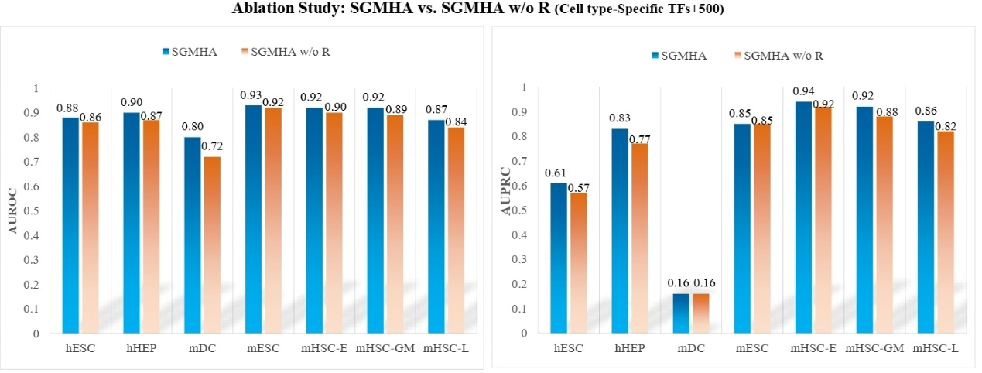
Supplementary Figure 5 Ablation study comparing SGMHA and its variant SGMHA w/o R on the TFs+500 dataset.

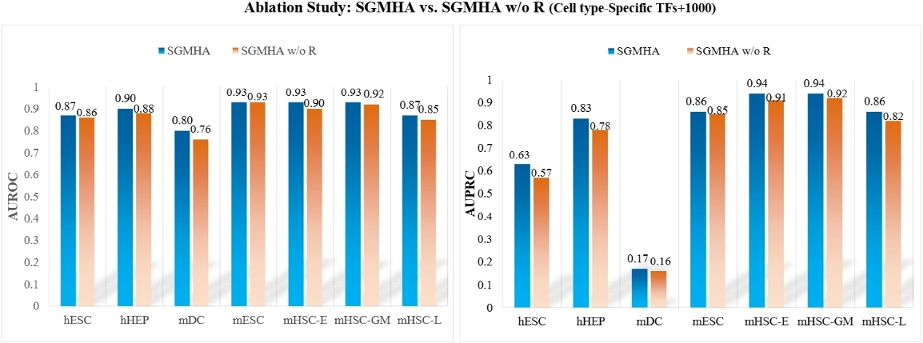
Supplementary Figure 6 Ablation study comparing SGMHA and its variant SGMHA w/o R on the TFs+1000 dataset.

